Level Design Documentation Template (Replace this with your level title)

Contents

High Level Design Overview 3

Main Objectives 3

Secondary Objectives 3

Design Motivations 3

Key Elements 3

Expected Player Experience 3

Overview Map 3

Points of Interest 3

Aesthetic (Look and Feel) 3

Enemy Placement Map 3

Pathway Maps 3

Golden Paths 3

Conflict Points 3

Choke points 3

Level Pacing 3

Rewards 3

Challenges 3

Flowchart 3

Balance Considerations 3

Expected Issues 3

Testing Plan 3

Mitigation Strategy 3

# High Level Design Overview

## Main Objectives – Defeat the boss and escape the area.

## Secondary Objectives- Pass through all the areas, so you can understand all the enemies and how the doors can open.

## Design Motivations- Design motivation was Doom64 level 1 as it was that I found very much intriguing

## Key Elements- The key elements of the map are the acid room in which the player must go across the floor that’s filled with acid by jumping over the tiles placed. Then there is the maze in which the player must find the key to unlock the door to the next room. The last element room would be the boss room as the player has to face all the enemies he has faced so far and the boss.

## Expected Player Experience- The expected player experience is going to be satisfaction of clearing the level, despair of unable to clear the level or unsatisfied with the time they took to clear the level.

# Overview Map

## Points of Interest- The point of interest in the game are first the start of the game, where the player learns all the game mechanics before proceeding ahead. Second it would be the mini boss fight which is in 5th room as the player fights a bit harder enemy and learns how super ammo learns so he knows its importance. Third would be the projectile room or the 8th room as the player must go across a room with acid tiles and projectile shooting across the room in a pattern, so the player must understand the pattern to break it and go across it. Fourth and the last would be the boss room as the player has to face all the enemies he has faced so far and the boss. Also, I have made the boss room look like an exit, feel like an exit but its not. This is to deceive the player to catch him off guard.

## 

## Aesthetic (Look and Feel)

This is the bubble map of the peril map

These are the annotated versions of the level

This is the level being made till section 6

This is the complete level before the changes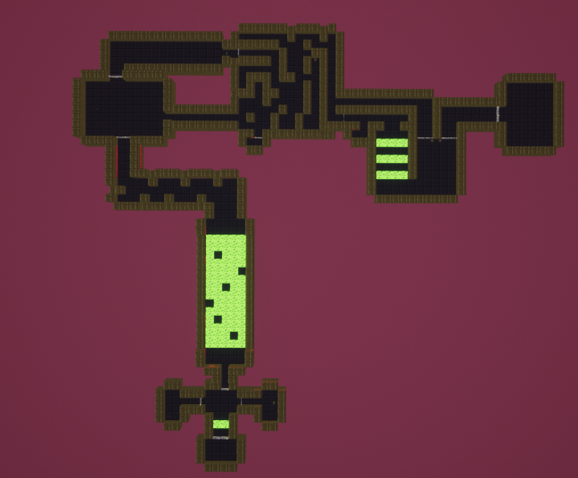

This is the updated level. I removed the hidden pathway from section 5 and added it as a path in section 9, it soley up to the player if he wants to go there and activate the lever to open the door to the items that are loced at the entrance of section 8. I also increased the size of the boss room to give the player a bit more space to move around.

Here are few pictures of the level showcasing all the areas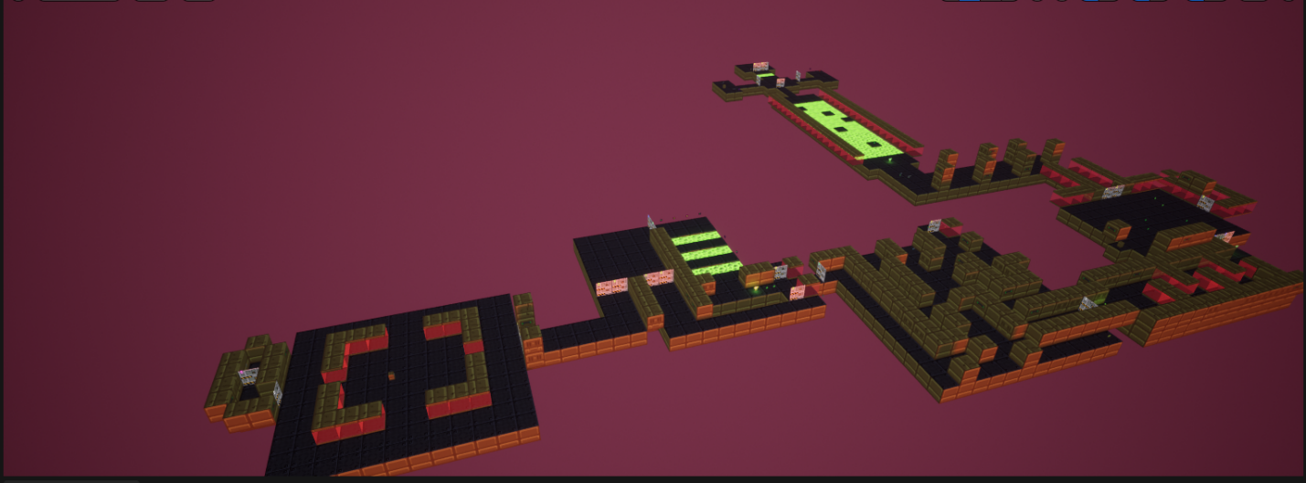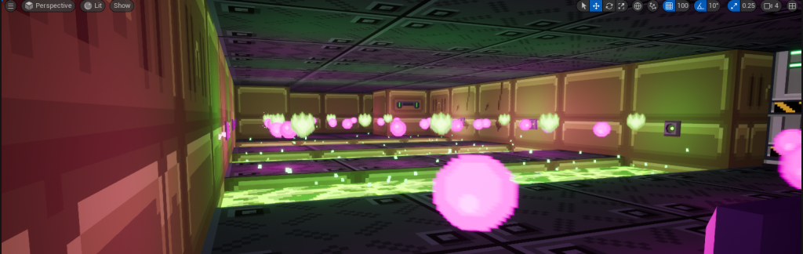

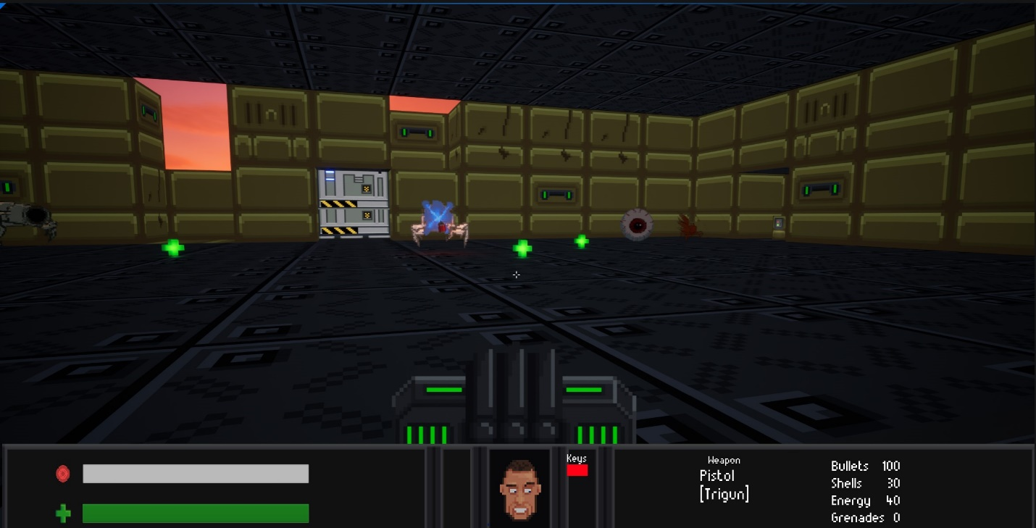

# Enemy Placement Map

Here is the enemy placement map of the whole level

Green- start

Red-End

Yellow-Path to maze end

Purple-Secrete door

Pink-Gun Ammo

Dark Blue-Health

Light Blue-Key

Orange-Enemy

Black-Door

# Pathway Maps

## Conflict Points

## Choke points

# Level Pacing

## Rewards

The reward pattern is in this manner-

Section 2 gives player plasma rifle.

Section 3 gives player health.

Section 4 gives player trigun and health.

Section 5 gives player special ammo and regular ammo.

Section 6 gives player health and pistol ammo.

Section 7 gives player health, ammo and grenade launcher(if they find the button to open the door to the room which has the launcher in it).

Section 8 gives player health.

Section 9 gives player health and ammo.

Section 10 gives player health and ammo.

## Challenges

The challenge for the player to reach the end. It is in a progressive manner, so player starts from the basic enemy to difficult enemies, so he learns their attack pattern and how to defeat them ahead. While killing the enemy’s player must keep his ammo in check as there aren’t many ammo pickups of few gun types.

## Flowchart

Here is the flow of the game in a bubble format

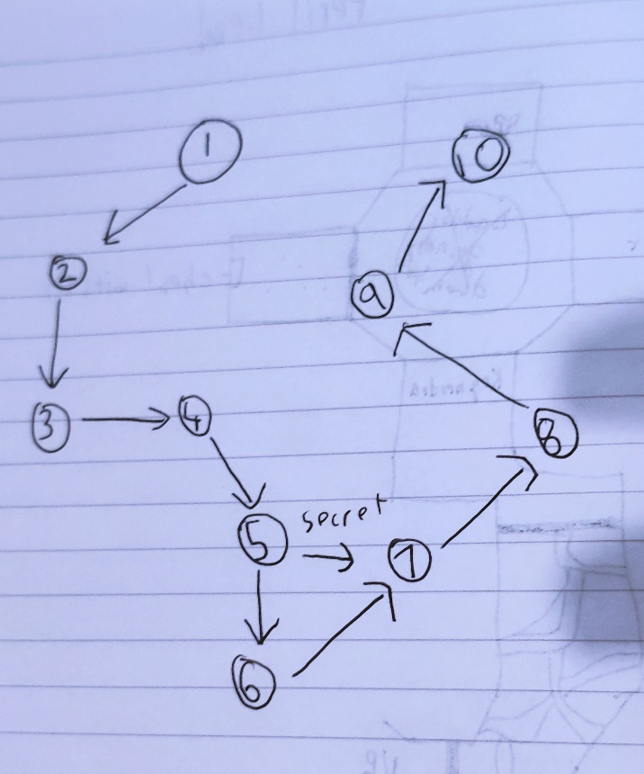

# Balance Considerations

## Expected Issues

The expected issue was too much ammo, less ammo, enemies are difficult to handle, enemies are too easy to kill, player are confused in navigation around in the maze and there are less health pickups.

## Testing Plan

Players will play the game and there kills, and time will be noted. After that they will be asked about their opinion on the level and what did they like and did not like.

## Mitigation Strategy